**2.1 Development of current perspectives on management:**

**Several ideas Drucker introduced that now underlie the organization and practice of management:**

* Workers should be treated as assets.
* The corporation could be considered a human community.
* There is “no business without a customer.”
* Institutionalized management practices are preferable to charismatic cult leaders.

**Six practical reasons for studying this chapter:**

1. **Understanding of the present.** “Sound theories help us interpret the present, to understand what is happening and why,” say Christensen and Raynor.
2. **Guide to action.** Good theories help you make predictions and enable you to develop a set of principles that will guide your actions.
3. **Source of new ideas.** It can also provide new ideas that may be useful to you when you come up against new situations.
4. **Clues to the meaning of your managers’ decisions.** It can help you understand your firm’s focus, where the top managers are “coming from.”
5. **Clues to** **the meaning of outside events.** It may allow you to understand events outside the organization that could affect it or you.
6. **Producing positive results.** It can help you understand why certain management practices—such as setting goals that stretch you to the limit (stretch goals), basing compensation and promotion on performance, and monitoring results—have been so successful for many firms.

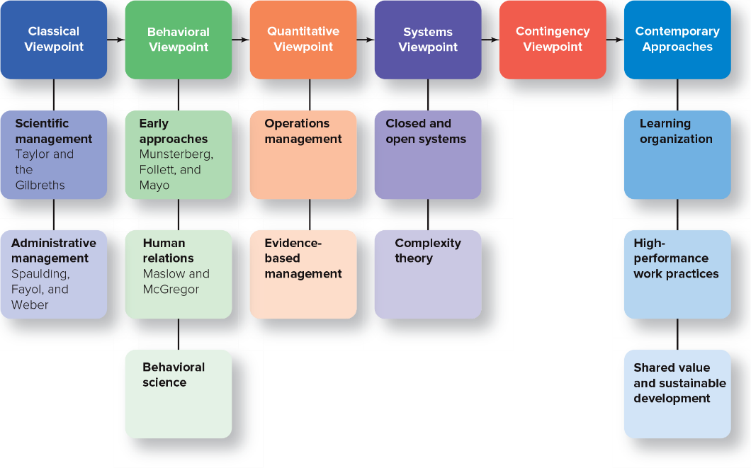

**2.2 Classical viewpoint: scientific and administrative management:**

**Classical viewpoint** – emphasized finding ways to manage work more efficiently. Assumed that people are rational. It had two branches—scientific and administrative—each of which is identified with particular pioneering theorists.

**Scientific management** - Applied the scientific study of work methods to improving the productivity of individual workers. Concerned with the jobs of individuals. Two of its chief proponents were Frederick W. Taylor and the team of Frank and Lillian Gilbreth.

**Frederick Taylor 4 principles of scientific management:**

1. Evaluate a task by scientifically studying each part of it (not by using old rule-of-thumb methods). This leads to the establishment of realistic performance goals for a job.
2. Carefully select workers with the right abilities for the task.
3. Give workers the training and incentives to do the task with the proper work methods.
4. Use scientific principles to plan the work methods and ease the way for workers to do their jobs.

**Motion studies** – breaking down each worker’s job into basic physical motions and then training workers to use the methods of their best-performing co-workers.

**Differential rate system** – more efficient workers earn higher rates of pay.

**Therblig** – made up word coined by Frank Gilbreth. The term refers to 1 of 17 basic motions workers can perform. By identifying the therbligs in a job, Gilbreth and his wife, Lilian, were able to help workers eliminate unnecessary motions and reduce their fatigue, thereby increasing productivity.

**Administrative management –** Concerned with managing the total organization. Among the pioneering theorists were Charles Clinton Spaulding, Henri Fayol, and Max Weber.

**Charles Clinton Spaulding and the “fundamental necessities” of management:**

* He proposed eight “necessities” of management based on his experiences working in his father’s fields as a boy and later leading the North Carolina Mutual Life Insurance Company.
* He is recognized as the “Father of African-American Management” and published his classic article in the *Pittsburgh Courier* in 1927.
* Spaulding’s “necessities” went beyond the task orientation of scientific management, thereby broadening the view of what it takes to effectively manage people and organizations. He suggested that considerations such as the need for authority, division of labor, adequate capital, proper budgeting, and cooperation and teamwork were essential for smooth organizational operations. He also was one of the first management practitioners to highlight the need to enrich “the lives of his organizational and community family” while simultaneously focusing on making a profit

**Henri Fayol and the functions of management:**

* Fayol was not the first to investigate management behavior, but he was the first to systematize it.
* Fayol was the first to identify the major functions of management—planning, organizing, leading, and controlling, as well as coordinating—the first four of which you’ll recognize as the functions providing the framework for this and most other management books.

**Max Weber and the rationality of bureaucracy:**

A better-performing organization, he felt, should have five positive bureaucratic features:

1. A well-defined hierarchy of authority.
2. Formal rules and procedures.
3. A clear division of labor, with parts of a complex job being handled by specialists.
4. Impersonality, without reference or connection to a particular person.
5. Careers based on merit.

**Problem with the classical viewpoint:**

* A flaw in the classical viewpoint is that it is mechanistic: It tends to view humans as cogs within a machine, not taking into account the importance of human needs.

Why the classical viewpoint is important:

* The essence of the classical viewpoint was that work activity was amenable to a rational approach, that through the application of scientific methods, time and motion studies, and job specialization it was possible to boost productivity. Indeed, these concepts are still in use today as scientific management is at the center of industries like quick-serve restaurants and manufacturing. The results are visible every time you visit a McDonald’s or see images of an auto manufacturing plant. The classical viewpoint also led to such innovations as management by objectives and goal setting.

**2.3 Behavioral viewpoint: behaviorism, human relations, and behavioral science:**

**Behavioral viewpoint** – emphasizes the importance of understanding human behavior and motivating employees toward achievement. The behavioral approach developed over three phases: early behaviorism, the human relations movement, and behavioral science.

The three people who pioneered behavioral theory were Hugo Munsterberg, Mary Parker Follett, and Elton Mayo.

**Hugo Munsterberg:**

* Called “the father of industrial psychology,” German-born Hugo Munsterberg had a PhD in psychology and a medical degree and joined the faculty at Harvard University in 1892.
* His ideas led to the field of *industrial psychology,* the study of human behavior in workplaces, which is still taught in colleges today.
* Munsterberg suggested that psychologists could contribute to industry in three ways. They could:

1. Study jobs and determine which people are best suited to specific jobs.
2. Identify the psychological conditions under which employees do their best work.
3. Devise management strategies to influence employees to follow management’s interests.

**Mary Parker Follett:**

* Instead of following the usual hierarchical arrangement of managers as order givers and employees as order takers, Follett thought organizations should become more democratic, with managers and employees working cooperatively.

The following ideas were among her most important:

1. Organizations should be operated as “communities,” with managers and subordinates working together in harmony.
2. Conflicts should be resolved by having managers and workers talk over differences and find solutions that would satisfy both parties—a process Follett called integration.
3. The work process should be under the control of workers with the relevant knowledge, rather than of managers, who should act as facilitators.

* With these and other ideas, Follett anticipated some of today’s concepts of “self-managed teams,” “worker empowerment,” and “interdepartmental teams”—that is, members of different departments working together on joint projects.

**Elton Mayo:**

**Hawthorne effect** - Employees worked harder if they received added attention, if they thought that managers cared about their welfare, and that supervisors paid special attention to them.

Ultimately, the Hawthorne studies were faulted for being poorly designed and not having enough empirical data to support the conclusions. Nevertheless, they succeeded in drawing attention to the importance of “social man” (social beings) and how managers using good human relations could improve worker productivity. This in turn led to the so-called human relations movement in the 1950s and 1960s.

**Human relations movement -** The two theorists who contributed most to the human relations movement—which proposed that better human relations could increase worker productivity—were Abraham Maslow and Douglas McGregor.

**Abraham Maslow and the hierarchy of needs:**

* Proposed his famous *hierarchy of human needs* (physiological, safety, love, esteem, and self-actualization) in 1943. As a humanist, Maslow advocated that employees have an innate desire to be self-actualized, which means to be all that they can be.

**Douglas McGregor:**

* ***Theory X*** represents a pessimistic, negative view of workers. In this view, workers are considered to be irresponsible, to be resistant to change, to lack ambition, to hate work, and to want to be led rather than to lead.
* ***Theory Y*** represents a human relations outlook—an optimistic, positive view of workers as capable of accepting responsibility, having self-direction and self-control, and being imaginative and creative.
* The principal contribution offered by the Theory X/Theory Y perspective is that it helps managers understand how their beliefs affect their behavior. For example, Theory X managers are more likely to micromanage, which leads to employee dissatisfaction, because they believe employees are inherently lazy.

**The Behavioral Science Approach -** Relies on scientific research for developing theories about human behavior that can be used to provide practical tools for managers. The disciplines of behavioral science include psychology, sociology, anthropology, and economics

**2.4 Quantitative viewpoints: Operations Management and Evidence-Based Management**

**Quantitative management** - The application of quantitative techniques, such as statistics and computer simulations, to management. The two branches of quantitative management are operations management and evidence-based management.

**Operations management** - focuses on managing the production and delivery of an organization’s products or services more effectively. In the day-to-day running of the company, operations management consists of all the job functions and activities in which managers schedule and delegate work and job training, plan production to meet customer needs, design services customers want and how to deliver them, locate and design company facilities, and choose optimal levels of product inventory to keep costs down and reduce backorders.

* **Supply chain** - the process of creating the product, starting with designing and obtaining raw materials for physical goods or technology for services and going all the way through delivery to customers’ hands, and sometimes even beyond to responsible disposal or recycling.

**Evidence-based management** - Entails translating principles based on best evidence into organizational practice, bringing rationality to the decision-making process. based on the belief that “facing the hard facts about what works and what doesn’t, understanding the dangerous half-truths that constitute so much conventional wisdom about management, and rejecting the total nonsense that too often passes for sound advice will help organizations perform better.”

**2.5 Takeaways from the systems view of management:**

**Systems viewpoint** - Regards the organization as a system of interrelated parts. By adopting this point of view, you can look at your organization both as (1) a collection of **subsystems**—parts making up the whole system—and (2) a part of the larger environment.

**The four parts of a system:**

1. **Inputs** - Are the people, money, information, equipment, and materials required to produce an organization’s goods or services. Whatever goes into a system is an input.
2. **Transformational processes** - Are the organization’s capabilities in management, internal processes, and technology that are applied to converting inputs into outputs. The main activity of the organization is to transform inputs into outputs.
3. **Outputs** - Are the products, services, profits, losses, employee satisfaction or discontent, and the like that are produced by the organization. Whatever comes out of the system is an output.
4. **Feedback** - Information about the reaction of the environment to the outputs that affects the inputs. Are the customers buying or not buying the product? That information is feedback.

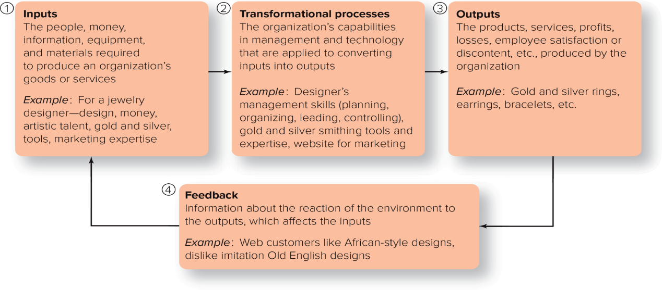

**Closed system** - Has little interaction with its environment; that is, it receives very little feedback from the outside. The classical management viewpoint often considered an organization a closed system. So does the management science perspective, which simplifies organizations for purposes of analysis. However, any organization that ignores feedback from the environment opens itself up to possibly spectacular failures.

**Open system** - Continually interacts with its environment. Today nearly all organizations are, at least to some degree, open systems rather than closed. Open systems have the potential of producing synergy. Open systems stress multiple feedback from both inside and outside the organization, resulting in a continuous learning process to try to correct old mistakes and avoid new ones.

**Synergy** - The idea that two or more forces combined create an effect that is greater than the sum of their individual effects, as when a guitarist, drummer, and bassist combine to play a better version of a song than any of them would playing alone.

**Complexity theory** - The study of how order and pattern arise from very complicated, apparently chaotic systems. Complexity theory recognizes that all complex systems are networks of many interdependent parts that interact with each other according to certain simple rules. Used in strategic management and organizational studies, the discipline seeks to understand how organizations, considered as relatively simple and partly connected structures, adapt to their environments.

**2.6 Explaining why there is no best way to manage in all situations:**

**Contingency viewpoint** - Emphasizes that a manager’s approach should vary according to—that is, be contingent on—the individual and the environmental situation. The beauty, and simplicity, of contingency theory lies in the proposition that there is not one best way to manage. Rather, effective management requires using the most appropriate theory or tool for a specific situation. The contingency viewpoint would seem to be the most practical of the viewpoints discussed so far because it addresses problems on a case-by-case basis and provides solutions specific to a certain situation or dilemma.

**2.7 Define how managers foster a learning organization:**

Management theory continues to evolve to tackle the challenges facing companies today. Three contemporary approaches to management include***learning organizations, high-performance work practices,* and *shared value and sustainable development****.*

**Learning organization: sharing knowledge and modifying behavior:**

**Learning organization** - An organization that actively creates, acquires, and transfers knowledge within itself and is able to modify its behavior to reflect new knowledge. Note the three parts of a learning organization:

1. **Creating and acquiring knowledge.** In learning organizations, managers try to actively infuse their organizations with new ideas and information, which are the prerequisites for learning. They acquire such knowledge by constantly scanning their external environments, by hiring new talent and expertise when needed, and by devoting significant resources to training and developing their employees.
2. **Transferring knowledge.** Individual managers should actively work to transfer knowledge throughout the organization, reducing barriers to sharing information and ideas among employees. One consultant suggests three strategies for managers: share your personal success story and challenges overcome; be ready to learn any and everything from peers and employees; and align your learning goals for the company with its business goals.
3. **Modifying behavior.** Learning organizations are nothing if not results oriented. First, managers should make sure the learning or training opportunity meets a real employee or organizational need. Does it solve a specific problem, and how? The link between learning and performance improvement, and the way the improvement will be measured, should be clear to employees as well. Next, both formal and informal learning experiences should be followed up with surveys or other measures to see whether employees are applying the new skills or information or need more coaching or encouragement from management.

**High-performance work practices:**

The job of management, according to this viewpoint, is to create human resource (HR) practices that foster employee development and overall well-being. These practices are called [**high-performance work practices (HPWPs)**](javascript:void(0);) because they focus on enhancing employees’ ability, motivation, and opportunity to contribute, and thus improve an organization’s ability to effectively attract, select, hire, develop, and retain high-performing personnel.

* ***Ability-enhancing practices:*** Formal selection tests, structured interviews, hiring standards or selectivity, high pay, and training opportunities.
* ***Motivation-enhancing practices***: Providing rewards based on individual and group performance and use of formal performance evaluation systems and merit-based promotion systems.
* ***Opportunity-enhancing practices:*** Employee involvement via formal participation processes, ongoing communication and information-sharing practices, and autonomy in making work-related decisions.
* Research supports the recommendation that managers should strive to create HPWPs. Findings revealed that HPWPs were associated with lower turnover and absenteeism and higher employee commitment and extra-role behavior. HPWPs also were related to greater organizational performance, financial performance, efficiency, and creativity.

**Shared value and sustainable development:**

* Shared value and sustainable development look beyond short-term profits and focuses on the environmental and social costs of doing business.
* Sustainable development focuses on meeting the needs of the present without compromising the ability of future generations to meet their own needs.
* Companies have now developed management positions such as chief sustainability officer, VP of corporate responsibility, and environmental program manager to be accountable for a company’s sustainability strategy, policies, and initiatives.
* The growing importance of shared value and sustainable development has led the United Nations (UN) to tackle the issue. During the UN’s Global Compact Summit in 2007, the organization launched Principles for Responsible Management Education (PRME).
* The mission of PRME is to “transform business and management education, research and thought leadership globally, while promoting awareness about the Sustainable Development Goals [SDGs], and developing the responsible business leaders of tomorrow.”
* There are 17 SDGs, ranging from poverty to climate action to gender equality. All 193 member states of the UN have adopted a plan to meet the SDGs by 2030

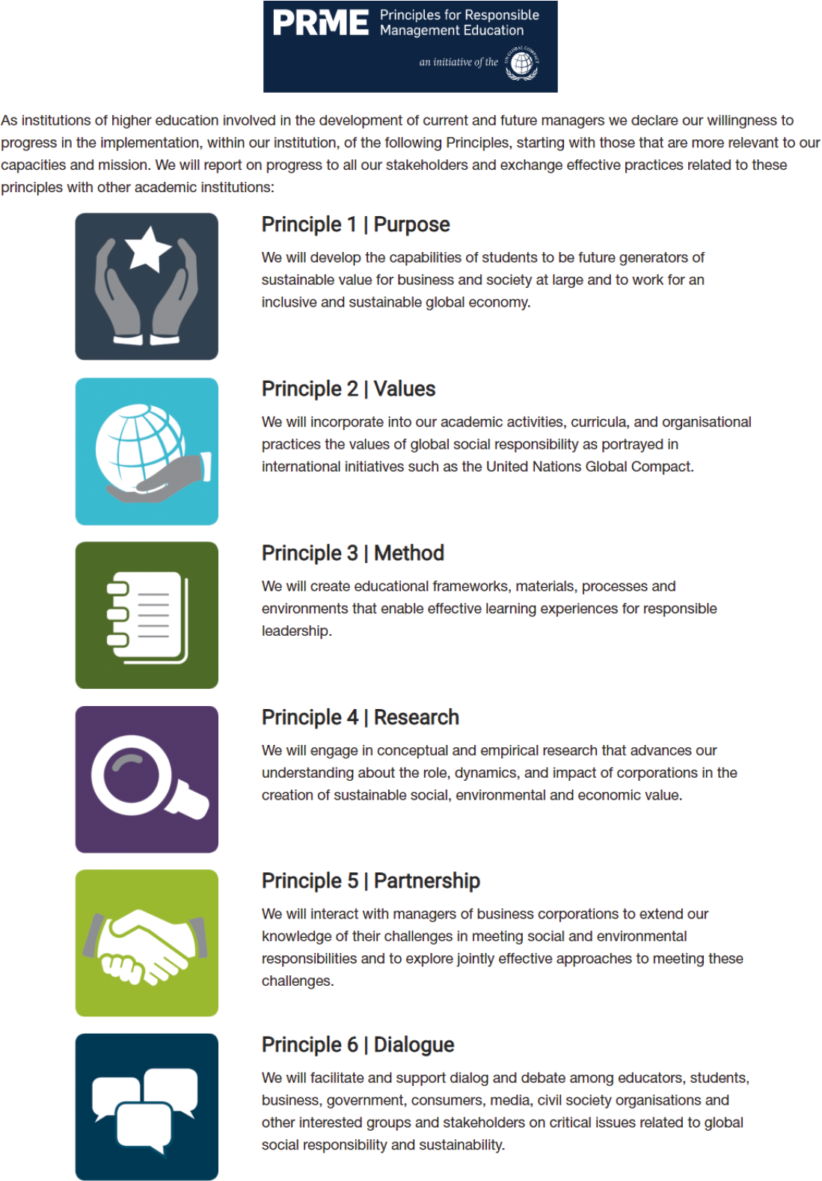

**2.8 Describe how to develop the career readiness competency of understanding the business:**

**learn the following eight things about a company before showing up at a job interview:**

1. **The company’s mission and vision statements**. These statements tell you why the company exists and what it wants to become or achieve over time.
2. **The company’s core values and culture.** The values an organization endorses represent the foundation of its culture. You can find clues about this by studying a company’s website. Try to find a list of company values. What do these values tell you about the company? Next, look for statements that inform you about how the company treats its employees. For example, does the company support empowerment and employee development? Look at any photos posted online and consider what they tell you. If you see pictures only of products and not of people, for instance, it suggests the company really cares about products.
3. **The history of the company**. When was the company founded? What were the values and background of the founder(s)? Try to find out how the company evolved, grew, or changed over the years.
4. **Key organizational players.** It’s important to demonstrate this knowledge during a job interview. Who holds important positions in the company? What are their backgrounds? You can find this out by reading the employer’s “About” page and top employees’ bios.
5. **Who are you interviewing with?** Aside from key organizational players, you should also find out the names and titles of the people you’re likely to interview with, particularly those higher up the chain of command.
6. **The company’s products, services, and clients.** What are people saying about the company’s products and services? You can explore this by locating reviews or comments about the company’s products and services. It would also be useful to try the company’s products and services. This would enable you to speak directly from experience.
7. **Current events and accomplishments**. Look for current news stories about the company and examine its website for a list of accomplishments. Note what this information reveals about the company and decide whether it matches what you learned about the company’s mission, vision, stated values, and organizational culture. Inconsistencies are a red flag.
8. **Comments from current or previous employees.** Talk to anyone you know at the company. Ask their opinion about working there and how they feel about management and corporate policies. Search websites like Glassdoor to find inside information such as salary ranges and company reviews